EXPERIMENT 5
NAME: Gokul S
ROLL NO: 240701148

TASK ANALYSIS AND MANAGEMENT
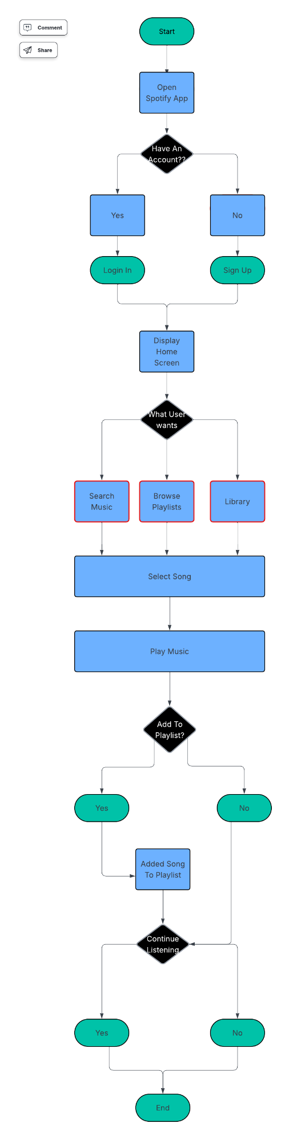
WIREFRAME
SCREEN 1
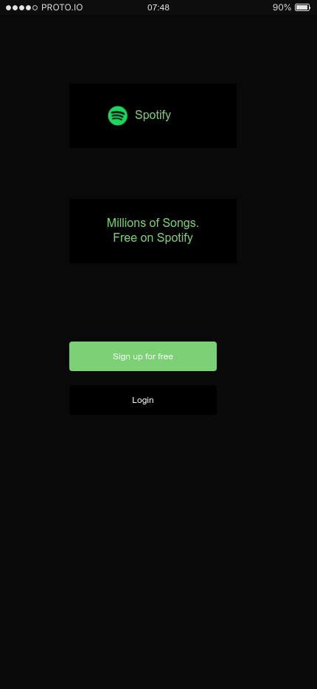

SCREEN 2


SCREEN 3
